

**Project Report**

**Voltage Divider and Selector Circuit**

Department: Computer Science and Engineering (CSE)

**Semester:** Fall 2022

**Course Code:** CSE209

**Course Title:** Electrical Circuits

**Submitted by:**

**Name**  **Student ID**

B M Shahria Alam 2021-3-60-016

Sidratul Moontaha 2021-3-60-048 Antara Sarkar Rupa 2021-3-60-056

**Submitted to:**

**M. Saddam Hossain Khan**

Senior Lecturer,

Department of Computer Science and

Engineering

**Group Number: 01**

Date of report submission: **2 January 2023**

**Problem Discussion**

A 10V DC supply is available. In practice we need to use 10V, 5V, and 3V as supply voltage of a low current electrical circuit. We have to design a voltage divider circuit so that the desired voltage can be selected at the output.



**Design**

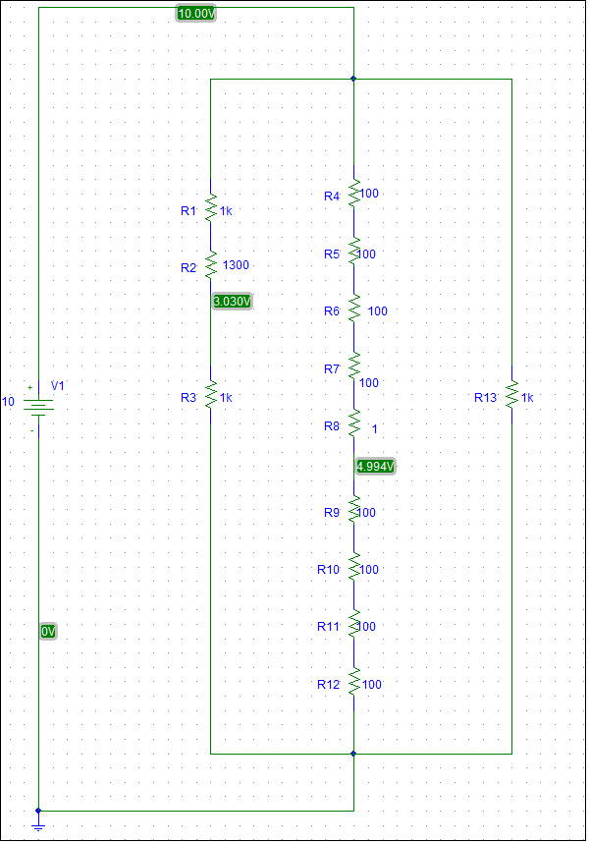**Figure: 01**

**3v**

**10v**

**5v**

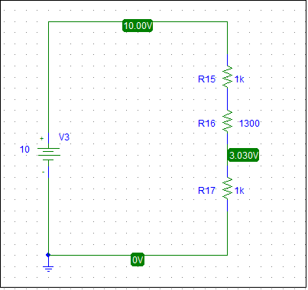

**i1**

**Figure:2**

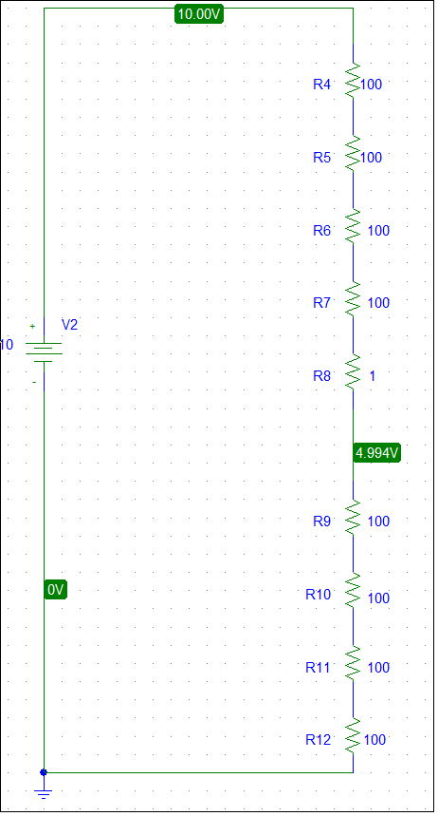

**i2**

**Figure:3**

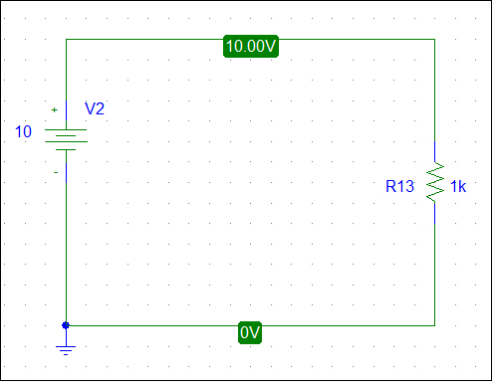

**i3**

**Figure: 4**

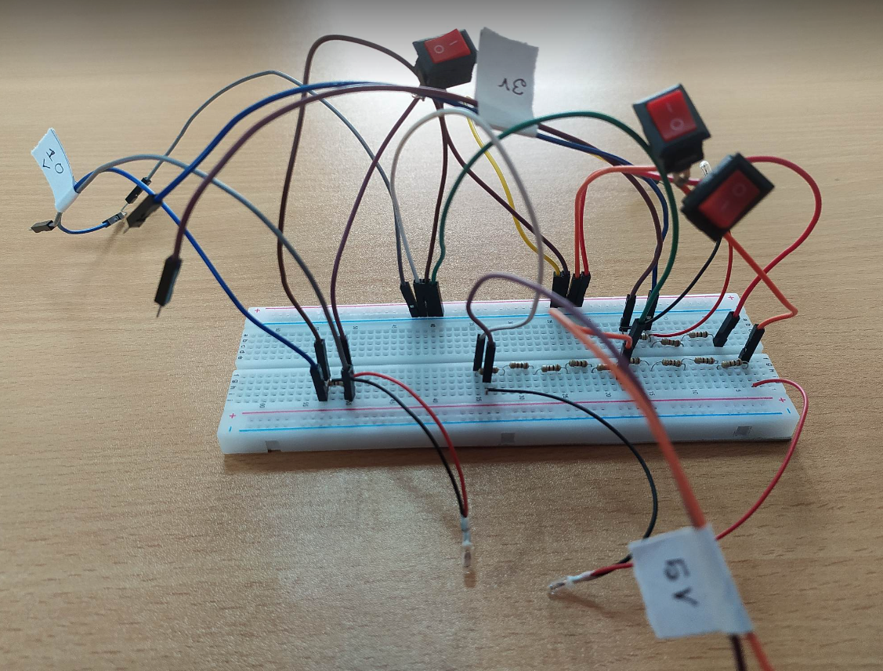

**Figure: 5**

We have used a 10V battery source to concrete the circuit. To find the resistor’s value we first assume the currents i1=3 mA, i2=10mA, i3= 9mAon the figure 2, 3 and 4. And we find the equivalent resistor of those circuits. Then demonstrate those into those circuits.

Here, R1=1000ΩR7=100 Ω

R2=1300 ΩR8=1 Ω

R3=1000 ΩR9=100 Ω

R4=100 ΩR10=100 Ω

R5=100 ΩR11=100 Ω

R6=100 ΩR12=100Ω

R13=1000 Ω

For figure 2, Applying voltage divider rule, we get,

3V=

**→**R3= =990Ω

So, 3V will be across R3 resistor.

The In figure 3, Applying voltage divider rule, we get,

5V=

**→**Rs= =400.5Ω

So, 5V will be across Rs resistors

Similarly, 10V will be across R13 resistors.

**Experimental Results**

To get 3 V we have to turn on switch 1 .

Here, Req=(R1+ R2+ R3)=3300Ω

i1=E/ Req= 10/3300=3.03mA

v1=R3*i1=1000*3.03=3.03V

To get 5 V we have to turn on switch 2 .

Here, Req=801Ω

i1=E/ Req= 10/801=12.48mA

Rs==( R8+ R9+ R10+ R11+ R12)=401Ω

v1=Rs*i1=401*12.48=5.00448V

Similarly, To get 10V we have to turn on switch 3 .

Here, Req=1000Ω

i1=E/ Req= 10/1000=10mA

v1=R3*i1=10*1000=10V

|  |  |  |  |
| --- | --- | --- | --- |
| Measured value of E (v) | Measured Value of v1 (V) | Measured Value of v2 (V) | Measured Value of v3 (V) |
| 10 | 2.8 | 4.9 | 9.9 |

|  |  |  |  |
| --- | --- | --- | --- |
| Name | Theoretically Values | Measured Values | Difference |
| E | 10 | 10 | 0 |
| v1 | 3 | 2.8 | 0.2 |
| v2 | 5 | 4.9 | 0.1 |
| v3 | 10 | 9.9 | 0.1 |

**Discussion:** Theoretically value and measured value are about the same. Negligible differences are found because of the temperature of the environment where we did the experiment to measure the value.

**Conclusion:** In this experiment project, we used a 9 V battery. Sometimes because of continuously using the battery, the voltage of the battery could be fallen. So, we can use the adopter source rather than the battery to get better results for accuracy.